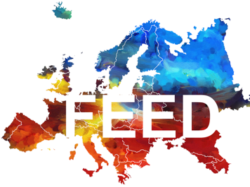

FOUNDATION FOR EUROPEAN ECONOMIC DEVELOPMENT
APPLICATION FOR FUNDING (2 pages maximum)

Applicant (name of researcher, initiative, scholarly society, charity…).
Main contact (name and academic affiliation)
Contact details (email, phone, postal address)
Names, affiliations, and contact details of additional co-applicants
International bank details (IBAN and BIC)
Project name
Project details (What do you need to fund? Please provide a short description of the project or activities.)
Amount requested (Please specify the amount requested from FEED and detail existing own resources as well as grants received from different funding bodies.)
Why do you need FEED to support this activity?
How would you acknowledge the support received from FEED?
Date and signature

Please submit to the Chairman, two pages maximum, between August 15 and September 1st morning. An answer will be sent by November.

